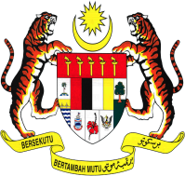
3rd National Nursing Research Colloquium (NNRC) 2019
Photo
(Passport size)
ORAL PRESENTATION
DECLARATION AND STRUCTURED ABSTRACT FORM

PRESENTING AUTHOR
Name:
Position:
Hospital/ Institution:
State:
E-mail/ HP No.:
STRUCTURED ABSTRACT FORM
- All section below must be completed.
- The official language of conference is English
- Please fill up the template below based on the instructions.
- The abstracts should be typed single space in MS Word format using 12 point font of Times New Roman/ Arial in not more than 250 words.
Method of presentation: Oral
Title:
Authors & Affiliations:
Introduction:
Methodology:
Results:
Discussion/ Conclusion:
Word Counts:

For secretariat use only
Date Received |  | Received by
Slot No |  | Date

Please email completed form to nursingcolloquium2019@gmail.com

Call for Abstract: 18 February 2019
Deadline of abstract submission: 22 March 2019
Notification of acceptance: ON or BEFORE 27 March, 2019

